**DA forms guide: Planning report template**

July 2017

This document is a guide only. It is not a statutory document.

© State of Queensland, July 2017. Published by the Department of Infrastructure, Local Government and Planning,   
1 William Street, Brisbane Qld 4000, Australia.

Creative Commons License**Licence:** This work is licensed under the Creative Commons CC BY 4.0 Australia Licence. In essence, you are free to copy and distribute this material in any format, as long as you attribute the work to the State of Queensland (Department of Infrastructure, Local Government and Planning) and indicate if any changes have been made. To view a copy of this licence, visit <http://creativecommons.org/licenses/by/4.0/>.

**Attribution:** The State of Queensland, Department of Infrastructure, Local Government and Planning.

The Queensland Government supports and encourages the dissemination and exchange of information. However, copyright protects this publication. The State of Queensland has no objection to this material being reproduced, made available online or electronically but only if it is recognised as the owner of the copyright and this material remains unaltered.

The Queensland Government is committed to providing accessible services to Queenslanders of all cultural and linguistic backgrounds. If you have difficulty understanding this publication and need a translator, please call the Translating and Interpreting Service (TIS National) on 131 450 and ask them to telephone the Queensland Department of Infrastructure, Local Government and Planning on 13 QGOV (13 74 68).

**Disclaimer:** While every care has been taken in preparing this publication, the State of Queensland accepts no responsibility for decisions or actions taken as a result of any data, information, statement or advice, expressed or implied, contained within. To the best of our knowledge, the content was correct at the time of publishing.

An electronic copy of this report is available on the Department of Infrastructure, Local Government and Planning’s website at [www.dilgp.qld.gov.au](http://www.dilgp.qld.gov.au).

Contents

Overview 4

What is a planning report? 4

How is the planning report template to be used? 4

What are planning instruments? 4

1.0 Summary 6

1.1 Development application details 6

1.2 Planning instrument details 6

1.3 Referral agencies 7

2.0 Site details 8

2.1 Site description 8

2.2 Surrounding land uses 10

3.0 Proposed development details 11

4.0 Planning assessment 13

4.1 Pre-lodgement 13

4.2 Key issues 13

4.2.1 Title of issue <identify issue> 14

4.2.2 Title of issue <identify issue> 14

4.3 Variations to planning provisions 14

4.4 Grounds for approval despite any conflicts 15

5.0 State assessment and other matters 16

5.1 State interests 16

5.1.1 Matters established in the Planning Regulation 16

5.1.2 State Planning Policy 16

5.2 Pre-lodgement meeting 17

5.3 Early referral responses 18

5.4 Assessment of referral requirements 18

5.4.1 Referral requirement [e.g. State-controlled road to SARA] 18

5.4.2 Referral requirement [e.g. Clearing vegetation to SARA] 18

6.0 Summary of supporting information 19

7.0 Conclusion 20

8.0 Appendices 21

Appendix X [delete if not relevant] 21

Appendix X [delete if not relevant] 21

Appendix X [delete if not relevant] 21

# Overview

## What is a planning report?

The development assessment (DA) forms require a planning report to be prepared and submitted along with the development application that is seeking approval for a proposed development.

A planning report provides further information about the land where a development is proposed, as well as further details about the proposal. It also provides a summary of the assessment of the proposed development against the requirements of a planning scheme and other planning instruments such as the State Planning Policy.

The planning report should include the following information:

* site details
* overview of the proposed development
* planning assessment
* referral assessment
* summary of supporting information.

The department has prepared this template as a tool to help applicants prepare a planning report.

## How is the planning report template to be used?

This planning report template encourages a ‘report-by-exception’ approach. When it comes to the assessment component, a planning report should only discuss the key issues and matters where a proposed development does not exactly meet the requirements of, or conflicts with, a planning scheme or other planning instrument. When this occurs, the applicant should put forward an alternative solution to the planning scheme outcomes or demonstrate why the proposed development should be approved despite conflicts with the planning requirements.

This template incorporates prompts and guidance to assist applicants complete and provide the necessary information in a planning report submitted along with the development assessment forms. As not all elements of this report will be necessary for all development applications, the planning report can be tailored to suit the nature of the particular application.

## What are planning instruments?

Planning instruments set out the requirements for particular developments. Planning instruments that may need to be considered are:

* the State Planning Policy (SPP)
* the relevant regional plan
* the State Development Assessment Provisions (SDAP)
* the relevant local government planning scheme
* any temporary local planning instrument (TLPI).

<Insert title page, which includes a short description of proposed development, e.g. Development Permit – Material Change of Use for ### or Development Permit – Reconfiguring a Lot: # lots into # lots.>

<Insert address of premises.>

<Enter month and year development application will be submitted.>

# Summary

## 1.1 Development application details

|  |  |
| --- | --- |
| **Proposed development:** | <Insert brief description of the proposed development, e.g. Shop – 300m2.> |
| **Type of approval sought:** | <Insert type of approval, e.g. Development Permit for Material Change of Use for Shop and Preliminary Approval for Operational Works for Excavation and Filling.> |
| **Site address:** | <Insert site address.>  <Insert site suburb, state and postcode.> |
| **Real property description:** | <Insert real property description, e.g. Lot 5 on RP181825.> |
| **Site area:** | <Insert area of subject land, e.g. 300m2.> |
| **Assessment manager:** | <Insert name of the assessment manager, e.g. Logan City Council.> |
| **Owner details:** | <Insert owner details, e.g. John Smith.> |
| **Applicant details:** | <Insert details of applicant, e.g. Sara Beach C/- Planning Consultant Pty Ltd.> |

## 1.2 Planning instrument details

|  |  |
| --- | --- |
| **State planning policy:** | <Insert state planning policy details, e.g. *Strategic airports and aviation facilities*, *Water quality*, or *Coastal environment*.> |
| **Regional plan:**  **Designation:** | <Insert the applicable regional plan and designation, e.g. SEQ Regional Plan 2009–2031 (version commenced 2 May 2014), urban footprint designation.> |
| **Planning scheme:** | <Insert planning scheme document name and version, e.g. Brisbane City Plan 2014.> |
| **Applicable preliminary approval:** | <Insert details of applicable preliminary approvals (if any), e.g. MCU1002/02/8998 MCU for Isaac Estates.> |
| **Strategic framework:** | <Insert details of applicable sections of the strategic framework.> |
| **Zone:** | <Insert applicable zone, e.g. General residential.> |
| **Local plan:** | <Insert applicable local plan (if any), e.g. Loganholme Local Area Plan.> |
| **Level of assessment:** | <Insert the level of assessment for each development aspect, e.g. code or impact.> |
| **Applicable overlays:** | <Insert applicable overlays, e.g. Natural hazards.> |
| **Applicable codes:** | <Insert applicable codes, e.g. Landscape work code or Child care centre code.> |

## 1.3 Referral agencies

|  |  |
| --- | --- |
| **Referral requirement** | **Referral agency and role** |
| <Insert applicable referral requirement, e.g. schedule 9 for building work, schedule 10 for all other development. Schedule references will need to include the part, division and table reference. | <Insert name of referral agency and whether the referral agency is advice or concurrence, e.g. Department of Infrastructure, Local Government and Planning – Concurrence.> |
| <Insert applicable referral requirement.> | <Insert name of referral agency and whether the referral agency has limitations on their powers (e.g. may give advice only or no limitations listed).> |

Referrals are often required if the proposed development has the potential to affect a state jurisdiction   
(e.g. state-controlled roads). Where a referral is required, your development application will need to be referred to parties other than the assessment manager for assessment.

To determine if your development application requires referral and to whom you must refer it, please see schedules 9 and 10 of the Planning Regulation 2017. The Department of Infrastructure, Local Government and Planning provides DA mapping, which aids in identifying some referral requirements. This is available from [www.dilgp.qld.gov.au](http://www.dilgp.qld.gov.au). If you are unsure, please contact a planning consultant or your local council for further information.

If your development application does not require any referral, you should state that there are no applicable referrals relevant to your development application.

# Site details

## Site description

The site description should provide context of where the site is located at a local and regional level. You should include a description of the site itself.

Provide site photos to show features of the site and existing use, surrounding land uses and site frontages. You may include as many photos as required to accurately represent all features of the site.

Mapping provides context for the subject site. You should provide both an aerial and satellite image, with a north point pointing north, within this section. Aerial images (see figure 1) are best for clearly defining lot boundaries, different land uses (e.g. parks) and road networks. Satellite images (see figure 2) will show different features, such as vegetation and access points. Ensure that you clearly identify any applicable premises on all mapping.

**Table 1: Site description**

|  |  |
| --- | --- |
| **Site characteristic** | **Description** |
| Existing land use | <Insert details of any existing land uses of the site, e.g. house.> |
| Existing structures | <Insert details of any existing structures located on the site, e.g. four-storey office building located at the north-eastern corner of the site.> |
| Frontage and access | <Insert frontage and access details of the site, e.g. 20 metre frontage to Short Street.> |
| Topography and views | <Insert topography and views of the site, e.g. flat topography with a one-metre fall to the road frontage.> |
| Existing vegetation | <Insert details of any existing vegetation on site, including the type, size, location and quantity, e.g. small grouping of leopard trees at the south-western corner adjacent to the road frontage.> |
| Existing waterways | <Insert details of any existing waterways on or surrounding the premises, e.g. Broadwater 300 metres east of subject site.> |

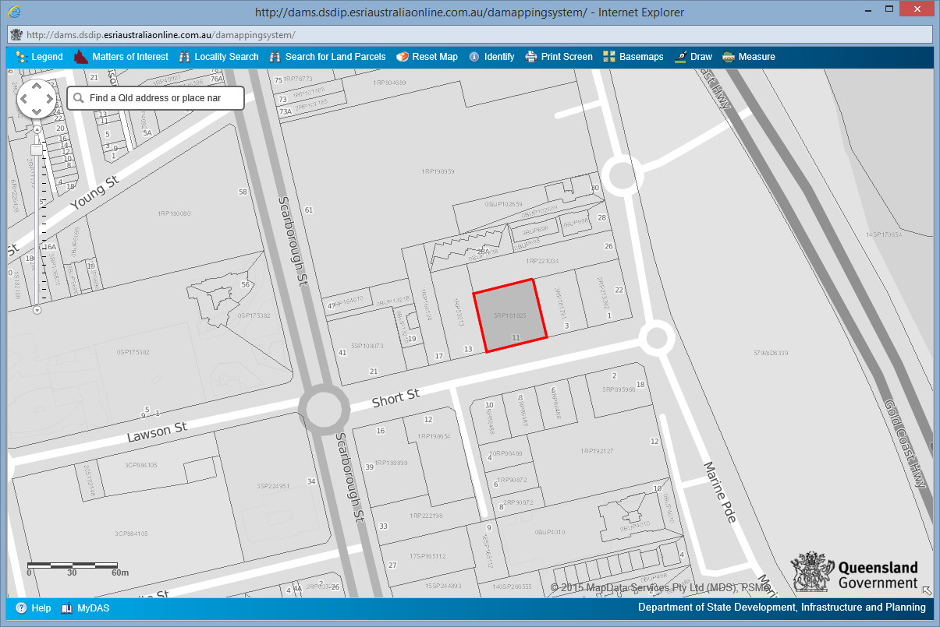

**Figure 1: Example of aerial view and site identification**Source: DA Mapping System

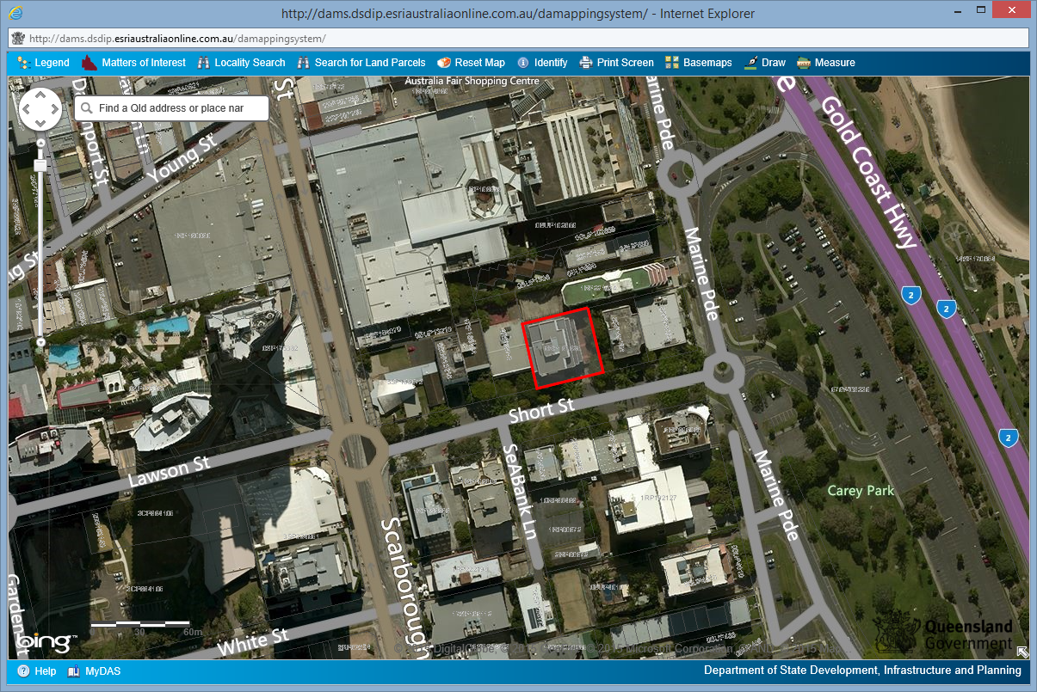

**Figure 2: Example of satellite view and site identification**Source: DA Mapping System

## 

## Surrounding land uses

Surrounding land uses are important to identify as they may affect the proposed development, or vice versa. The description of each surrounding land use can be brief, e.g. a house or shop. You may also wish to provide a number of photographs of adjoining or surrounding land uses.

**Table 2: Surrounding land uses**

|  |  |  |
| --- | --- | --- |
| **Surrounding land uses** | | **Photos** |
| North | <Insert surrounding land use(s) to the north.> |  |
| South | <Insert surrounding land use(s) to the east.> |  |
| East | <Insert surrounding land use(s) to the south.> |  |
| West | <Insert surrounding land use(s) to the west.> |  |

# Proposed development details

|  |
| --- |
| Provide a brief overview of the proposed development. The DA forms and relevant plans attached to your development application will provide many intricate details of each aspect. This section provides an opportunity to give details not displayed in other documents, such as how the proposed development will function (e.g. operating hours) or how it will benefit the surrounding community. The section should summarise the following for each development aspect:   * Describe the development aspects. * Describe what the development application is proposing. * State the purpose of the proposed development. |

<Insert overview of the proposed development.>

**Table 3: Summary of development aspects**

|  |  |
| --- | --- |
| **Material change of use  (If your development application does not include a material change of use, please delete this section)** | |
| **Building height** | <Provide maximum building height.> |
| **Gross floor area (GFA)** | <Provide the GFA of the proposed development.> |
| **Non GFA site use area** | < Provide non-GFA site use area of the proposed development.> |
| **Site coverage** | < Provide total site area covered by the proposed development and percentage of site covered.> |
| **Car parking** | < Provide car-parking details of the proposed development.> |
| **Site access** | < Provide site access details for the proposed development.> |
| **Proposed lots** | < Provide the proposed number of lots involved with the proposed development.> |
| **Proposed servicing arrangements** | < Provide any servicing or infrastructure arrangements that are involved with the proposed development, including details of service vehicle provision.> |
| **Building height** | < Provide maximum building height.> |
| **Gross floor area (GFA)** | < Provide the GFA of the proposed development.> |
| **Building or operational work  (If your development application does not include building or operational work, please delete this section)** | |
| **Building work** | < Provide the nature of the building work, e.g. building, repairing, altering, underpinning, moving or demolishing a building> |
| **Value of proposed work** | < Provide the dollar value of the proposed building work.> |
| **Operational work** | < Provide the nature of the operational work e.g. Road works, storm water, water infrastructure, drainage works etc.> |
| **Value of proposed work** | <Provide the dollar value of the proposed operational work.> |
| **Reconfiguring a lot  (If your development application does not include reconfiguring a lot, please delete this section)** | |
| **Existing lots** | <Provide the total number of existing lots making up the premises.> |
| **Reconfiguration** | <Provide the nature of the lot reconfiguration, e.g. subdivision, boundary realignment, creating an easement giving access to a lot from a constructed road or dividing land into parts.> |
| **Proposed number of lots (subdivision)** | <Provide the number of additional lots being created and their intended final use, e.g. residential, commercial, industrial or other.> |
| **Stages (subdivision)** | <Provide whether the proposal involves multiple stages and if so details of the proposed stages.> |
| **Lease agreement details (subdivision)** | <Provide how many parts are being created and what their intended final use is.> |
| **Boundary realignment (boundary realignment)** | <Provide the reason for the boundary realignment.> |
| **Dimensions (boundary realignment)** | <Provide the current and proposed dimensions following the boundary realignment for each lot forming the premises.> |
| **Easement (easement)** | <Provide the dimensions and nature of the proposed easement.> |

# Planning assessment

## 4.1 Pre-lodgement

Pre-lodgement meetings or advice are highly recommended to ensure you identify all relevant planning matters, any issues surrounding the proposed development, and any supporting information requirements.

If you have completed multiple pre-lodgement meetings and received pre-lodgement advice, ensure the details of each instance are provided. If you have not undertaken a pre-lodgement meeting or received   
pre-lodgement advice for this development proposal, state that no pre-lodgement was undertaken as part of this development application.

A pre-lodgement meeting was undertaken with <insert council name> on <insert date of meeting> with <insert officer(s)> to discuss planning requirements and key issues applicable to this development application.

A copy of the pre-lodgement meeting minutes is contained in appendix X. [Number the appendix or delete line if not including this information as an appendix.]

**Table 4: Summary of key issues**

|  |  |  |
| --- | --- | --- |
| **Issue** | **Council response** | **Applicant response** |
| <Insert issue, e.g. Flood mapping indicates there is potential flood inundation on the eastern side of the premises.> | <Insert comments received from council,e.g. *‘*The potential flood risk is low; however, access should be moved to the northern side of the premises’. > | <Insert applicant’s response regarding the matter,e.g. *‘*Plans amended to provide access from the northern side of the premises (see attached site plan 01 in schedule 4).> |
|  |  |  |

## 

## 4.2 Key issues

|  |
| --- |
| This section should summarise the key planning issues associated with the proposed development.  Use each sub-heading below to identify and explain the key issues that relate to the application.  The key issues may relate to:   * Amenity (e.g. height, site coverage, setbacks, overlooking etc.) * Urban design * Setbacks * Landscaping * Flooding * Traffic * Acoustics * Odour * Heritage * Stormwater management * Views * Infrastructure * Waste management * Regional plan considerations * Health * Vegetation removalEnvironment. * Environment. |

**4.2.1 Title of issue <identify issue>**

<Explain the issue and discuss how the development proposal responds to this issue.>

### 4.2.2 Title of issue <identify issue>

<Explain the issue and discuss how the development proposal responds to this issue>

## 4.3 Variations to planning provisions

|  |
| --- |
| This section should, using table 5, summarise any variations to the planning provisions, including justification for the proposed variation and how the proposed variation addresses the requirements of the planning scheme. |

**Table 5: Proposed variations to the planning scheme**

|  |  |  |
| --- | --- | --- |
| **Ref.** | **Planning provision** | **Proposed variation and justification** |
|  |  |  |
|  |  |  |

## 4.4 Grounds for approval despite any conflicts

|  |
| --- |
| This section should use table 6 to detail any conflicts with the planning scheme and the reasons the development application should be approved despite those conflicts. |

**Table 6: Conflicts with the planning scheme**

|  |  |  |
| --- | --- | --- |
| **Ref.** | **Planning provision** | **Conflict and grounds for approval despite the conflict** |
|  |  |  |
|  |  |  |

# 5.0 State assessment and other matters

## 5.1 State interests

### 

### 5.1.1 Matters established in the Planning Regulation

|  |
| --- |
| This section should detail any matters established in the Planning Regulation 2017 that are relevant to this development application. Note that the previous State Planning Regulatory Provisions no longer exist. You will need to check the Planning Regulation for the relevant development assessment requirements. |

### 5.1.2 State Planning Policy

|  |
| --- |
| This section should detail the relevance of Part E of the SPP (State interest policies and assessment benchmarks) to your development application. Assessment benchmarks have been prepared for certain state interests to ensure that the state’s interests are appropriately considered by local governments when assessing development applications where the local government planning scheme has not appropriately integrated the state interests in the SPP. Generally, a local government planning scheme will detail which state interests have been considered in preparing the planning scheme.  Assessment benchmarks have been provided for the following state interests:   * Liveable communities * Mining and extractive resources * Water quality * Natural hazards, risk and resilience * Strategic airports and aviation facilities.   Identify below which state interests are relevant to your development application and provide commentary on how your development application complies or does not comply with the assessment benchmarks.  If a local government has reflected all the state interests in its planning scheme, the assessment benchmarks are not applicable. |

The SPP includes assessment benchmarks that may be applicable where a local government planning scheme does not adequately reflect the SPP.

The following assessment benchmarks are applicable and have been appropriately considered in preparing this development application:

|  |  |
| --- | --- |
| **State interest** | **Assessment against assessment benchmark** |
| <Insert relevant state interest.> | <Insert details on how your development application complies or does not comply with the assessment benchmarks for this particular state interest.> |
| <Insert relevant state interest.> | <Insert details on how your development application complies or does not comply with the assessment benchmarks for this particular state interest.> |

## 5.2 Pre-lodgement meeting

Attending a pre-lodgement meeting or requesting pre-lodgement advice from any applicable referral agency is highly recommended because it will ensure you identify all relevant referral requirements and are aware of any issues surrounding the proposed development and supporting information.

If you have completed multiple pre-lodgement meetings and received pre-lodgement advice, ensure the details of each instance are provided. If you have not attended a pre-lodgement meeting or received   
pre-lodgement advice for this development proposal, state that no pre-lodgement occurred as part of this development application.

If your development application does not require any referral, you can delete this section.

A pre-lodgement meeting was undertaken with the following referral agency/s.

|  |  |  |
| --- | --- | --- |
| **Entity meeting held with** | **Contact officer details** | **Date of meeting** |
| <Insert name of entity, e.g. the local government or SARA.> | <Insert the contact officer’s details, i.e. name, contact email and contact phone number. > | <Insert date of meeting/s.> |

A copy of the pre-lodgement meeting minutes is contained in appendix X. [Number the appendix or delete line if not including this information as an appendix.]

A summary of the key referral requirements is provided in table 7.

**Table 7: Summary of key referral requirements**

|  |  |  |  |
| --- | --- | --- | --- |
| **Referral requirement** | **Referral agency** | **Referral agency response** | **Applicant response** |
| <Insert applicable referral requirement e.g. Schedule 10, division 4, table 1.> | <Insert the name of the referral agency.> | <Insert a summary of the comments received from the referral agency, e.g. ‘The proposed access will have an impact on the safety and efficiency of the state-controlled road and should be moved’.> | <Insert applicant response regarding the matter, e.g. ‘Plans amended to provide access from the northern side of the site as agreed (see attached site plan in schedule 4)’.> |
|  |  |  |  |

## 5.3 Early referral responses

**Table 8: Early referral responses received**

|  |  |  |
| --- | --- | --- |
| **Referral requirement** | **Referral agency** | **Date of early referral response** |
| <Insert applicable referral requirement, e.g. Schedule 10, division 4, table 1.> | <insert |  |

A copy of all early referral responses is contained in appendix X. [Number the appendix or delete line if not including this information as an appendix.]

## 5.4 Assessment of referral requirements

|  |
| --- |
| This section should detail how the development proposal responds to each referral requirement that is the subject of the development application. This should include:   * A statement of whether the development proposal complies with the relevant provisions in SDAP; and * Any variation to SDAP, including justification for the variation. |

### 5.4.1 Referral requirement [e.g. State-controlled road to SARA]

<Insert a summary of the referral requirement, details of the relevant SDAP modules and a statement about whether the development proposal complies with the relevant SDAP modules.>

An assessment against the relevant SDAP codes is contained in appendix X. [Number the appendix or delete line if not including this information as an appendix.]

### 5.4.2 Referral requirement [e.g. Clearing vegetation to SARA]

<Insert a summary of the referral requirement, details of the relevant SDAP modules and a statement about whether the development proposal complies with the relevant SDAP modules.>

An assessment against the relevant SDAP codes can be found in appendix X. [Number the appendix or delete line if not including this information as an appendix.]

# 6.0 Summary of supporting information

|  |
| --- |
| Specialist reports cover information not provided by the DA forms, relevant plans or planning report. They provide expertise in particular fields that relate to certain development aspects.  For example, your development may require the following:   * Traffic impact assessment * Heritage impact report * Stormwater management report * Acoustic report.   Small-scale development, such as minor building works, often does not require any specialist reports. On the other hand, a development involving a new shopping centre would require a number of specialist reports. To ensure you are providing the correct information, you should contact your local council or organise a pre-lodgement meeting. |

<Insert a summary of findings for any attached supporting information documents and where they are attached. For further information, please see *DA forms guide*.>

**Table 9: Supporting documentation**

|  |  |  |  |  |
| --- | --- | --- | --- | --- |
| **Drawing/**  **Report title** | **Prepared by** | **Date** | **Reference no.** | **Version** |
| Aspect of development: <e.g. material change of use> | | | | |
| <Insert name of plan/report.> | <Insert name of author.> | <Insert date of preparation.> | <Insert document reference.> | <Insert document version.> |
| Aspect of development: <Aspect of Development e.g. Material Change of Use > | | | | |
| <Insert name of plan/report> | <Insert name of author.> | <Insert date of preparation.> | <Insert document reference.> | <Insert document version.> |

# 7.0 Conclusion

<Insert a summary of the key findings of the assessment of the proposed development, including justification for why the development application should be approved despite any variation and/or conflicts with the planning provisions.>

# 8.0 Appendices

The appendices contain information that is too lengthy to sit within the body of a planning report. You should keep code responses, relevant plans and supporting information and report these in the appendices.

Having this information in the appendices also allows it to be found easily and used in conjunction with the planning report for the development assessment.

Number your appendices alphabetically or chronologically.

## Appendix X [delete if not relevant]

[Attach response to relevant planning scheme assessment benchmarks.]

## Appendix X [delete if not relevant]

[Attach response to relevant SPP assessment benchmarks.]

## Appendix X [delete if not relevant]

[Attach response to relevant SDAP codes.]

|  |
| --- |

**Department of Infrastructure, Local Government and Planning**

1 William Street, Brisbane

**tel** 13 QGOV (13 74 68)  
**www.dilgp.qld.gov.au**