Template 4 – Waterway barrier works
(version 1.1)
This template must be completed and submitted with DA Form 1 – Development application details for all development applications operational works involving waterway barrier works.
It is mandatory to complete the details in all applicable parts in this form and provide any supporting information that is required to accompany your development application, unless stated otherwise.
Additional pages may be attached if there is insufficient space on this template for any questions.
Note: All terms used within this template have the meaning given under the Planning Act 2016, the Planning Regulation 2017, or the Development Assessment Rules (DA Rules), Fisheries Act 1994 and Fisheries Regulation 2008.

Part 1 – Development details

1) Has a Fish Movement Exemption Notice been issued for the proposed works? | Yes – a copy of the Fish Movement Exemption Notice for the proposed work is attached
 | No – details of how the proposed work provides for adequate fish movement is attached

2) What is the nature of the proposed waterway barrier(s)?  (tick all applicable boxes) | New construction | Raise existing
 | Temporary | Permanent
 | Partial | Bank to bank

3) What type is the proposed work?  (tick all applicable boxes)  Note: An individual section must be completed for each barrier relevant to this development application. Also ensure that the relevant plans that accompany the development application identify the location of existing works and proposed works. | Type | Number of barriers | Parts to complete
 | Dam, weir or a barrage |  | 2 only
 | Culvert |  | 3 only
 | Causeway |  | 4 only
 | Bridge pylon (abutments or pile foundations) |  | 4 only
 | Flow-control structure such as a floodgate |  | 4 only
 | Pollution-control device (e.g. trash rack or boom gate) |  | 4 only
 | Levee bank across a waterway |  | 4 only
 | Other – specify below (e.g. groyne, construction platform, sediment curtain, causeway) |  | 4 only

Part 2 – Constructing a new or raising/modifying an existing dam, weir, barrage, bund wall, coffer dam or other similar structures
Note: If the development application involves more than one barrier relating to this part, generate another part 2 and attach to the application.

4) What is the proposed development application seeking approval for? | New barrier | Raising/modifying an existing barrier

5) Briefly describe the type of barrier proposed (i.e. dam, weir, tidal barrage)

6) If the barrier is temporary (in place less than 12 months) how many days will the barrier be in place?

7) Will the barrier extend across the waterway from bank to bank? | Yes, go to question 8
 | No
7.1) What is the length of the proposed barrier? (across the waterway) |  | metres
7.2) What is the width of the waterway? (bank to bank) |  | metres

8) What is the purpose of the proposed barrier? (e.g. creating a new or increasing the capacity of the existing water storage, maintenance work)

9) What are the details of the proposed construction materials? (e.g. earth, concrete, rock fill, steel, timber, sand)

10) Provide the following details of the proposed barrier in reference to the diagrams below.  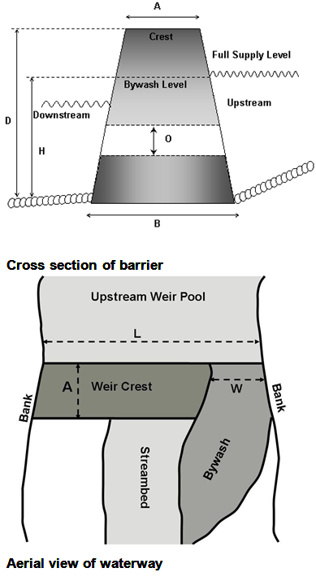 | Total crest height (D) |  | metres
 | Thickness (A) of crest |  | metres
 | Height of spillway/bywash (H) |  | metres
 | Width of spillway/bywash inlet (W) |  | metres
 | Base width (B) |  | metres
 | Internal diameter (O) of outlet pipe/works and discharge capacity |  | millimetres
 | Length of wall (L) |  | metres
 | Distance of backup from barrier wall at full supply level |  | metres
 | Volume of storage |  | megalitres
 | If raising an existing waterway barrier, additional height above existing crest |  | metres
 | If raising an existing waterway barrier, method of raising (e.g. capping crest, inflatable bag, gates etc.).

Part 3 – Constructing a new or modifying (including maintenance and replacement of) an existing culvert
Note: If the development application involves more than one culvert relating to this part, please generate another part 3 and attach to the application.

11) What is the nature of the proposed work? | Construction of a new culvert
 | Maintenance of an existing culvert
 | Replacement of an existing culvert

12) What is the purpose of the proposed culvert?

13) If the culvert is temporary (in place less than 12 months) how many days will the culvert be in place?

14) Will the culvert extend across the waterway from bank to bank? | Yes, go to question 15
 | No
14.1) What is the length of the proposed culvert? (across the waterway) |  | metres
14.2) What is the width of the waterway? (bank to bank) |  | metres

15) What type of culvert is proposed?  (Tick all applicable boxes) | Box culvert | Arch culvert | Pipe culvert
 | Combination culvert | Other – please specify

16) In reference to the diagrams below, provide the following details of the proposed culvert. | How many culvert cells are there?
 | What is the upstream downstream culvert cell length? |  | metres
 | What is the inside cell width of each culvert (or diameter of pipe culvert)? |  | metres
 | What is the internal height within the culvert cell? |  | metres
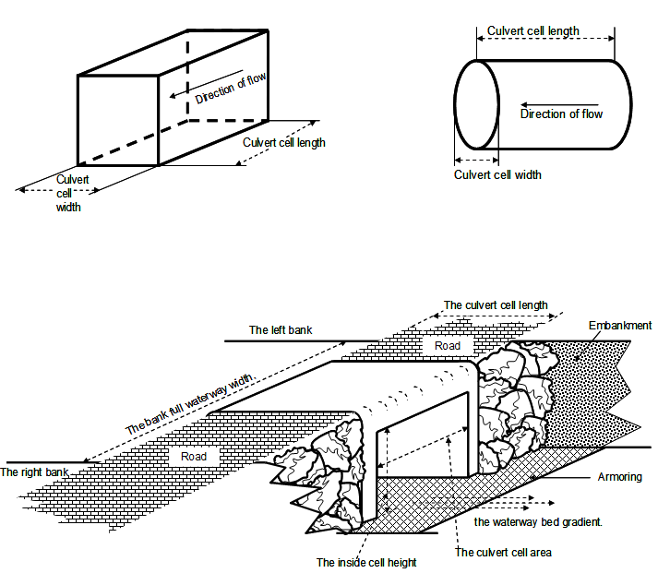

Part 4 – Constructing new or modifying (including maintenance and replacement) an existing waterway barrier except those listed in partS 2 and 3
Note: If the development application involves more than one barrier relating to this part, please generate another part 4 and attach to the application.

17) What is the nature of the proposed work? | Construction of a new barrier
 | Maintenance of an existing barrier
 | Replacement of an existing barrier

18) Briefly describe the proposed barrier.

19) If the barrier is temporary (in place less than 12 months) how many days will the barrier be in place?

20) Will the barrier extend across the waterway from bank to bank? | Yes, complete question 20.1 and 20.2
 | No
20.1) What is the length of proposed barrier? (across the waterway) |  | metres
20.2) What is the width of the waterway? (bank to bank) |  | metres

21) What is the purpose of the proposed barrier?

22) What is the maximum height of the proposed barrier above the existing bed level? |  | metres

23) What are the proposed construction materials? (e.g. earth, concrete, rock fill, timber, sand)

24) Does the barrier follow the natural gradient of the bed level? | Yes
 | No

