Template 2 – Taking or interfering with water in a watercourse, lake or spring
(version 1.1)

This template must be completed and submitted with DA Form 1 – Development application details for all development applications for operational works involving the taking or interfering with water in a watercourse, lake or spring by any of the following:
- Watercourse pump
- Water storage
- Gravity diversion from a watercourse
- Watercourse diversion, or
- Other work in a watercourse.

It is mandatory to complete the details in all applicable parts in this form and provide any supporting information identified on the form as being required to accompany your development application, unless stated otherwise.
Additional pages may be attached if there is insufficient space on this template for any questions.
Note: All terms used within this template have the meaning given under the Planning Act 2016, the Planning Regulation 2017, or the Development Assessment Rules (DA Rules).

Part 1 – Development details

1) Are the works existing?  Note: Ensure that the relevant plans that accompany the development application identify the location of existing works and proposed works. | Yes – provide construction date (if known)
 | No

2) What is the proposed development for?  (tick all applicable boxes) | Watercourse pump | Complete part 2 only
 | Water storage | Complete part 3 only
 | Gravity diversion from a watercourse | Complete part 4 only
 | Watercourse diversion | Complete part 5 only
 | Other work in a watercourse | Complete part 6 only

Part 2 – Watercourse pumps

3) What type of pump is proposed?  (tick all applicable boxes) | Centrifugal | Turbine | Helical rotor
 | Jet | Submersible | Piston
 | Cylinder pump and windmill |  | Other – specify below

4) What is the motor type of the proposed pump?  (tick all applicable boxes) | Diesel | Electric |  | Hydro
 | Petrol | Solar |  | Wind
 | Other – please specify

5) What are the details of the pump? | Inlet/bore (millimetres)
 | Outlet/stroke (millimetres)
 | Duty discharge (litres/sec)
 | Duty head (metres)

6) Is there any filling or excavation proposed in the watercourse, lake or spring? | Yes – additional information should be provided to assist with assessing the development application (e.g. location and extent of filling or excavation)
 | No

Part 3 – Water storage

7) What type of water-storage facility is proposed? | Dam | Excavation in a watercourse |  | Weir
 | Other – please specify

8) What is the proposed water-storage facility to be constructed from?  (tick all applicable boxes) | Earth | Sand |  | Rockfill
 | Sandbag | Earth and rockfill |  | Sheetpile
 | Concrete | Timber |  | Gabion
 | Other – please specify

9) What are the dimensions of the proposed water-storage facility?  (give dimensions to one (1) decimal point)  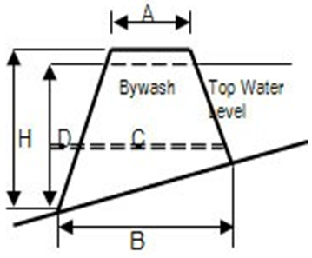 | Height to top (H) |  | metres
 | Crest width (A) |  | metres
 | Base width (B) |  | metres
 | Crest length |  | metres
 | Diameter of outlet pipe (C) |  | millimetres
 | Height of bywash/spillway above bed level |  | metres
 | Width of bywash/spillway |  | metres
 | Distance of back up at top water level |  | metres
 | Capacity of storage when at full supply level |  | megalitres
 | Storage area at full supply level |  | hectares

10) If excavation works are proposed, what are the details of these works?  (give dimensions to one decimal point) | Top dimensions
 | Width |  | metres
 | Depth |  | metres
 | Length |  | metres
 | Capacity |  | megalitres
 | Base dimensions
 | Length |  | metres
 | Width |  | metres

Part 4 – Gravity diversion from a watercourse

11) If a gravity channel is proposed for this gravity diversion, what are the details of the proposed channel?  (give dimensions to one decimal point)  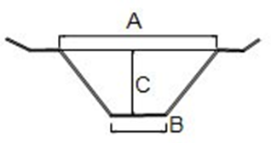 | Top width (A) |  | metres
 | Bottom width (B) |  | metres
 | Depth (C) |  | metres
 | Length |  | metres
 | Bed slope |  | ratio
 | Side slope |  | ratio
 | Flow capacity |  | m³/second

12) If a gravity pipeline is proposed for this gravity diversion, what are the details of the proposed pipeline?  (give dimensions to one decimal point)  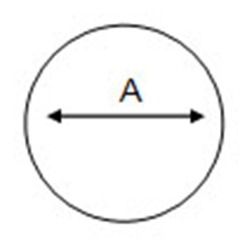 | Material type
 | Diameter (A) |  | millimetres
 | Length |  | metres
 | Number of proposed pipes
 | Bed slope |  |  | ratio
 | Flow capacity |  |  | m³/second

13) Is there any filling or excavation proposed in the watercourse or water body? | Yes – additional information should be provided to assist with assessment of the development application (e.g. location and extent of filling or excavation)
 | No

14) What is the purpose of the proposed gravity diversion? | Flood prevention | Divert watercourse
 | Erosion prevention | Other – please specify

Part 5 – Watercourse diversion

15) What are the details of the existing watercourse or water-body channel proposed to be diverted?  (give dimensions to one decimal point)  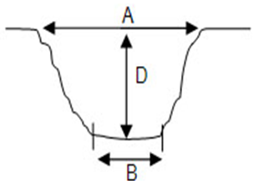 | Top width (A) |  | metres
 | Bottom width (B) |  | metres
 | Depth (D) |  | metres
 | Length |  | metres
 | Bed slope |  | ratio
 | Side slope |  | ratio
 | Flow capacity |  | m³/second

16) If the proposed method for diversion is earth or a lined channel, what are the details of the proposed channel?  (give dimensions to one decimal point) | Lining materials (e.g. PVC, steel)
 | Top width (A) |  | metres
 | Bottom width (B) |  | metres
 | Depth (C) |  | metres
 | Length |  | metres
 | Bed slope |  | ratio
 | Side slope |  | ratio
 | Flow capacity |  | m³/second

17) If a pipeline is proposed for this watercourse diversion, what are the details of the proposed pipeline?  (give dimensions to one decimal point) | Pipe material (e.g. PVC, steel)
 | Diameter (A) |  | millimetres
 | Length |  | metres
 | Number of proposed pipes
 | Bed slope |  | ratio
 | Flow capacity |  | m³/second

18) What is the purpose of the proposed watercourse diversion? | Flood prevention | Divert watercourse
 | Erosion prevention | Other – please specify

Part 6 – Other work in a watercourse

19) What are the details of the proposed works?

20) What are the details of the proposed construction materials?

