*To be eligible for appeal rights under the Planning Act 2016 submissions must be received within the period to make a submission stated above.*

Public notification requirements are in accordance with the *Planning Act 2016*

**PROPOSED DEVELOPMENT**

**HAVE YOUR SAY**

Bottom

**[Insert proposed development image]**

**[Insert proposed development image]**

[INSERT THE PROPOSED USE(S) OF THE LAND AS DEFINED IN THE PLANNING SCHEME]

**[Insert QR Code here if applicable]**

**[Insert proposed development image]**

**[Insert the street address of the site that the application relates to]**

**[Insert the real property (e.g. lot on plan)]**

**Approval sought: [Insert the types of approval sought (i.e. preliminary approval, development permit, and material change use)]**

**0**

**Application reference:** **[Insert application reference number i.e. MCUXXXXXXXXX]**

**Make a submission: [Insert period start and end date]**

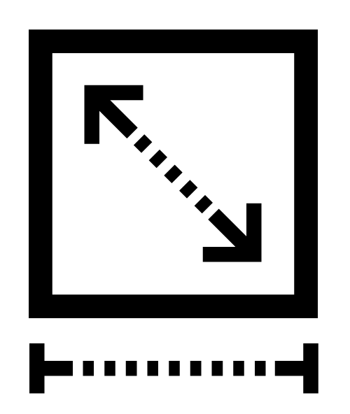

**Site cover**

[Insert proposed site coverage]

**Setbacks**

[Insert proposed side, rear and front setbacks]

**Building height**

[Insert proposed building height in metres of storeys at upper most projection]

**Lot size and frontage**

[Insert minimum lot size and minimum frontage]

**For further information and to view a copy of the application, contact:**

* [Insert assessment manager]
* [Insert assessment manager web address]
* [Insert assessment manager contact number]

**Submissions can be made to:**

* [Insert assessment manager]
* [Insert assessment manager postal address]
* [Insert assessment manager contact email]